phpMyAdmin Database System Views
The following screenshots show the MySQL/phpMyAdmin server tools used to monitor, manage, and review the database environment of the Bundoora Family Clinic system.
Advisor System
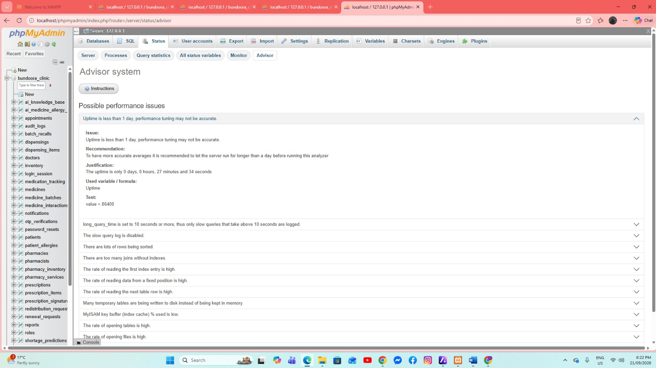
This screen displays phpMyAdmin recommendations for possible MySQL performance issues. It helps identify settings or server conditions that may need attention or optimization.

Server Monitor
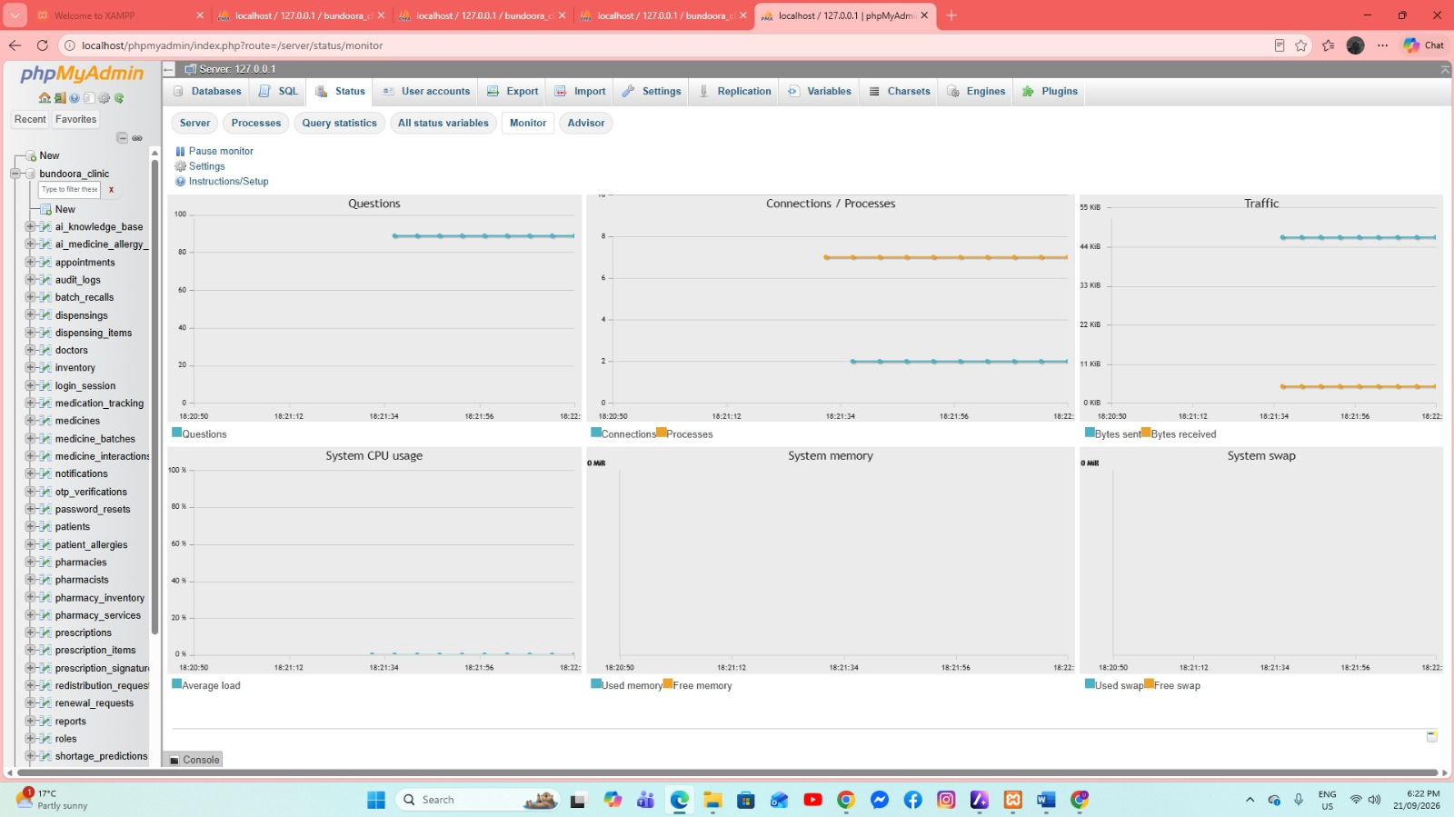
This page shows live charts for database activity such as queries, connections, network traffic, CPU usage, memory, and swap. It is useful for observing the current workload of the MySQL server.

All Status Variables
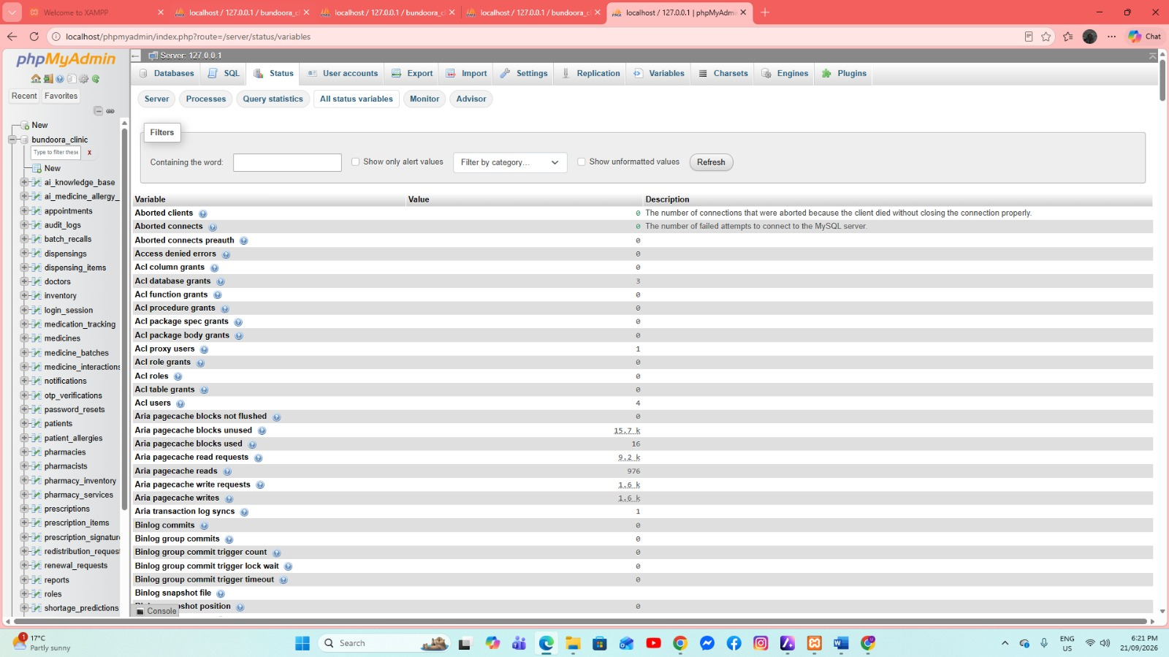
This screen lists MySQL status variables, their current values, and brief descriptions. These values provide technical information about the server’s activity and internal operations.

User Accounts Overview
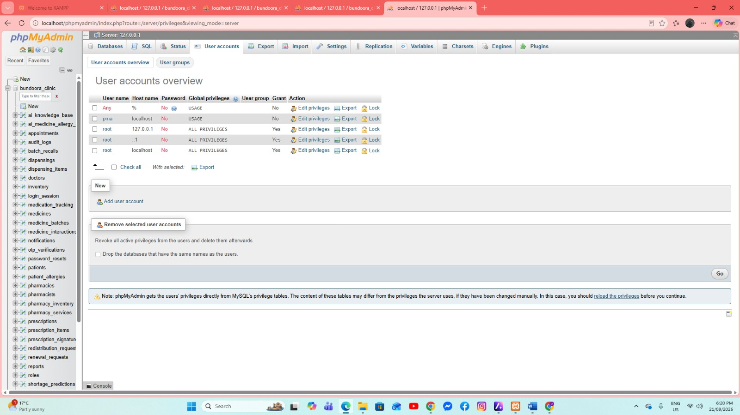
This page shows the available MySQL user accounts, host access, password status, and assigned privileges. It is used to manage database users and control their access permissions.

Query Statistics
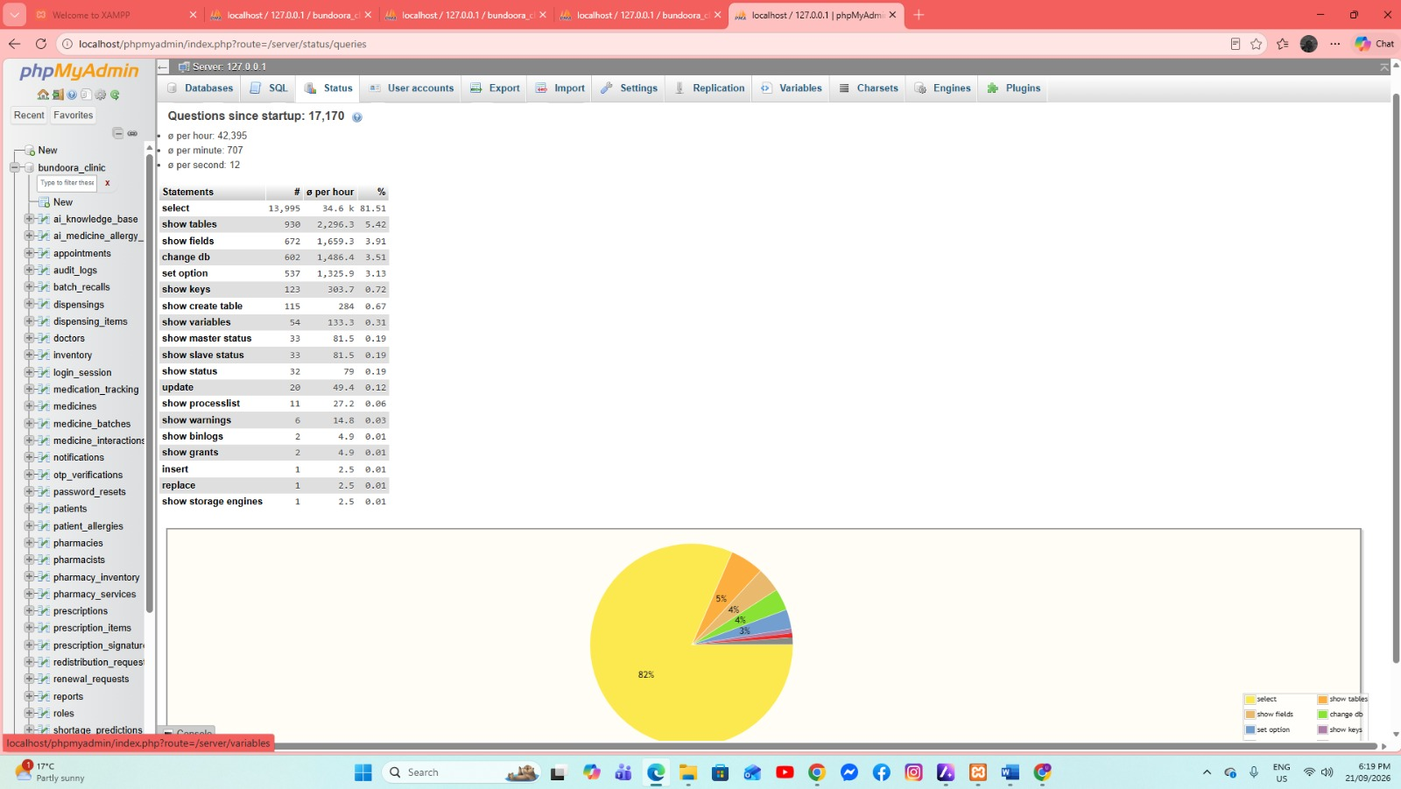
This screen summarizes the SQL statements processed since the server started. The table and chart help show which types of database queries are being used most frequently.

Database Processes
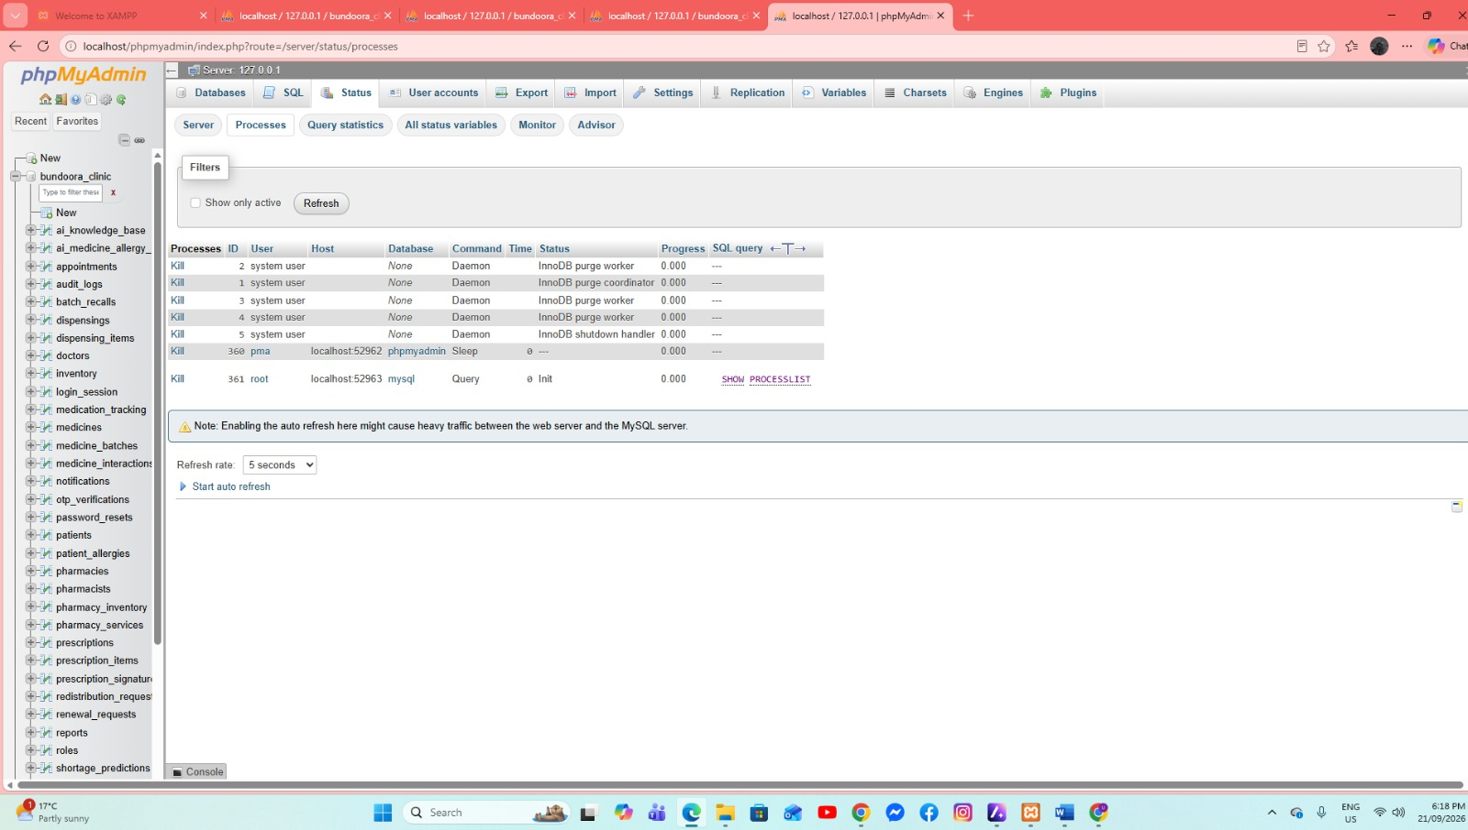
This page displays the active MySQL processes and connections, including the user, host, command, status, and running SQL query. It can help identify active or stalled database operations.

Server Status and Network Traffic
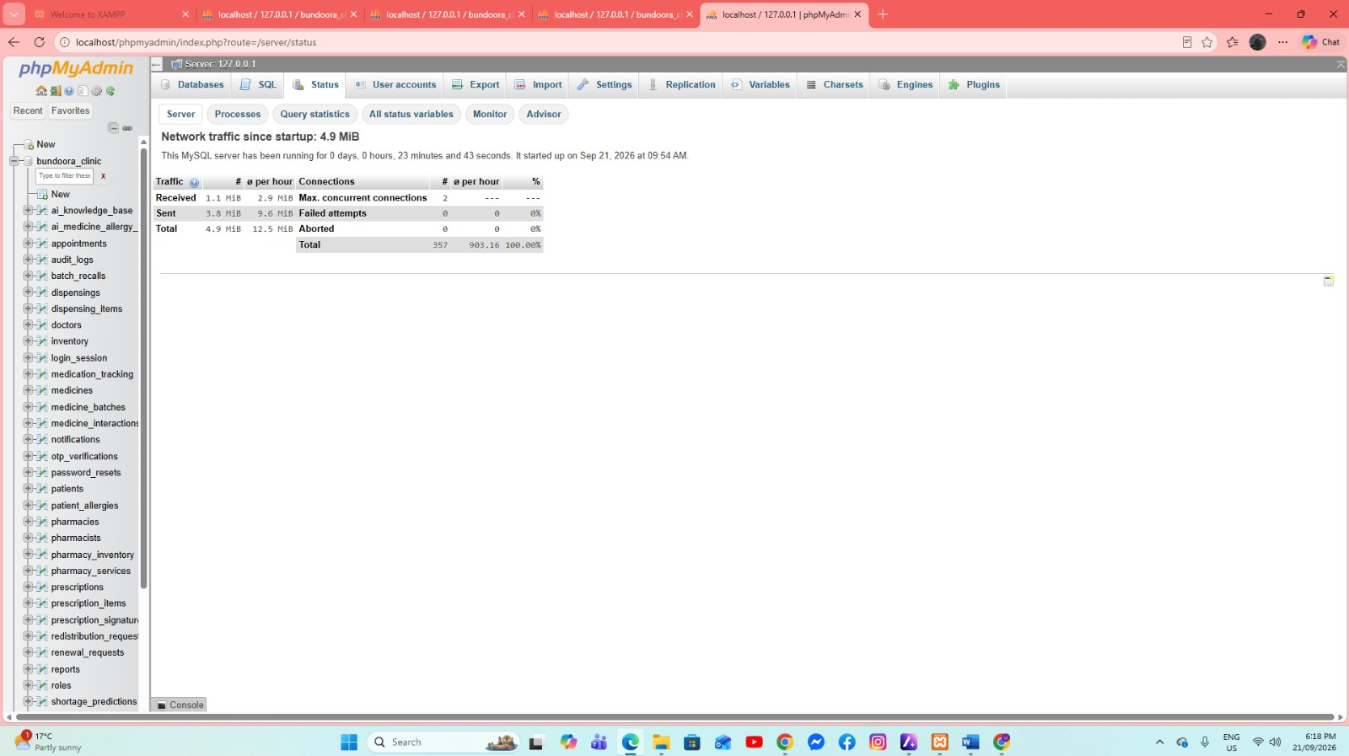
This screen presents server traffic and connection statistics since MySQL startup, including data received, data sent, total connections, failed attempts, and aborted connections.

